Lab – Researching WAN Technologies

1. Objectives

Part 1: Investigate Dedicated WAN Technologies and Providers

Part 2: Investigate a Dedicated Leased Line Service Provider in Your Area

1. Background / Scenario

Today’s broadband Internet services are fast, affordable, and secure using VPN technologies. However, many companies still find the need for a 24-hour dedicated connection to the Internet or a dedicated point-to-point connection from one office location to another. In this lab, you will investigate the cost and availability of purchasing a dedicated T1 Internet connection for your home or business.

1. Required Resources

Device with Internet access

1. Investigate Dedicated WAN Technologies and Providers

In Part 1, you will research basic characteristics of dedicated WAN technologies, and in Step 2, you will discover providers that offer dedicated WAN services.

* 1. Research WAN technology characteristics.

Use search engines and websites to research the following WAN technologies to complete the table below.

|  |  |  |  |  |  |
| --- | --- | --- | --- | --- | --- |
|  |  | **Last Mile Media** | | |  |
| **WAN Technology** | **Dedicated Connection (yes/no)** | **Copper (yes/no)** | **Fiber (yes/no)** | **Wireless (yes/no)** | **Speed/Range** |
| T1/DS1 |  |  |  |  |  |
| T3/DS3 |  |  |  |  |  |
| OC3 (SONET) |  |  |  |  |  |
| Frame Relay |  |  |  |  |  |
| ATM |  |  |  |  |  |
| MPLS |  |  |  |  |  |
| EPL (Ethernet Private Line) |  |  |  |  |  |

* 1. Discover dedicated WAN technology service providers.

Navigate to <http://www.telarus.com/carriers.html>. This webpage lists the Internet service providers (also known as carriers) that partner with Telarus to provide automated real-time telecom pricing. Click the links to the various carrier partners and search for the dedicated WAN technologies that they provide. Complete the table below by identifying each service provider’s dedicated WAN services, based on the information provided on the website. Use the extra lines provided in the table to record additional service providers.

|  |  |  |  |  |  |  |  |
| --- | --- | --- | --- | --- | --- | --- | --- |
| **Internet Service Provider** | **T1/DS1/PRI** | **T3/DS3** | **OC3 (SONET)** | **Frame Relay** | **ATM** | **MPLS** | **EPL Ethernet Private Line** |
| Comcast |  |  |  |  |  |  | x |
| Integra | x | x | x |  |  | x | x |
| tw telecom |  | x | x |  |  | x |  |
| AT&T |  |  |  |  |  |  |  |
| Cbeyond |  |  |  |  |  |  |  |
| Earthlink |  |  |  |  |  |  |  |
| Level 3 Communications |  |  |  |  |  |  |  |
| XO Communications |  |  |  |  |  |  |  |
| Verizon |  |  |  |  |  |  |  |
|  |  |  |  |  |  |  |  |
|  |  |  |  |  |  |  |  |
|  |  |  |  |  |  |  |  |

1. Investigate a Dedicated Leased Line Service Provider in Your Area

In Part 2, you will research a local service provider that will provide a T1 dedicated leased line to the geographical area specified. This application requires a name, address, and phone number before the search can be performed. You may wish to use your current information or research an address locally where a business might be looking for a WAN connection.

* 1. Navigate to <http://www.telarus.com/geoquote.html> to try GeoQuote.

GeoQuote is a web application that automates the search for WAN technology service providers, and provides price quotes in real-time. Fill in the required fields.

* + 1. Click the **Service Type** drop-down list and select **Data (High Speed Internet)**.
    2. Type your **First Name** and **Last Name**, your sample **Company**, and your **Email** address.
    3. Type the **Phone Number** to connect to the WAN. This number should be a landline number.
    4. Click the button marked **Step 2**.

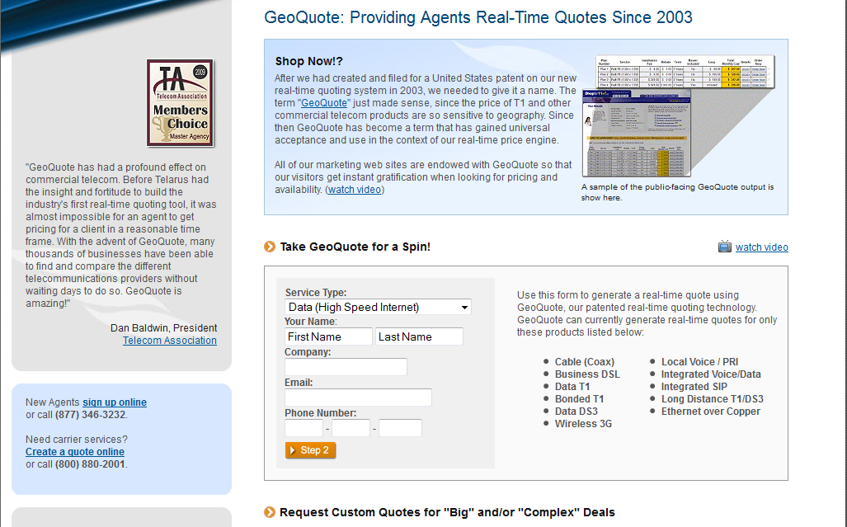

* 1. Select the service type.

Choose **Internet T1 (1.5 MB)** and scroll down to **Step 3** on the webpage.

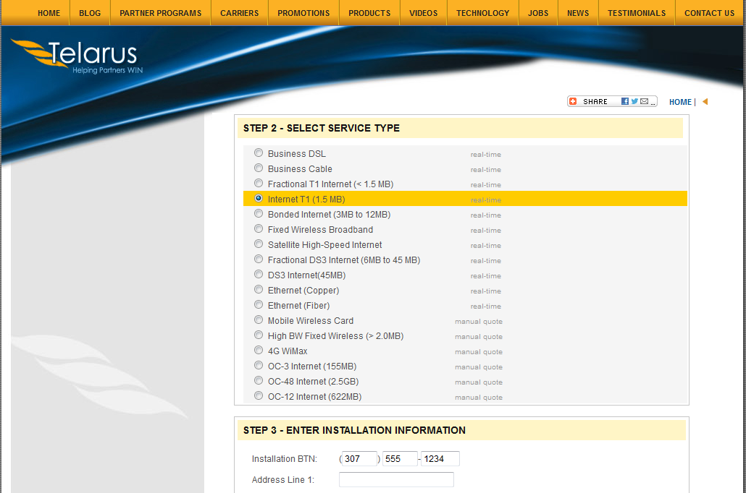

* 1. Enter installation information.
     1. In the **Installation BTN** field, enter your sample business telephone number. This should be a landline number.
     2. Enter your address, city, state, and zip code.
  2. Enter contact preferences.
     1. Do not click the first radio button (**Please call me ASAP at**), but do provide your contact telephone number.
     2. Click the **I am just window shopping** radio button.
     3. Click **Continue**.

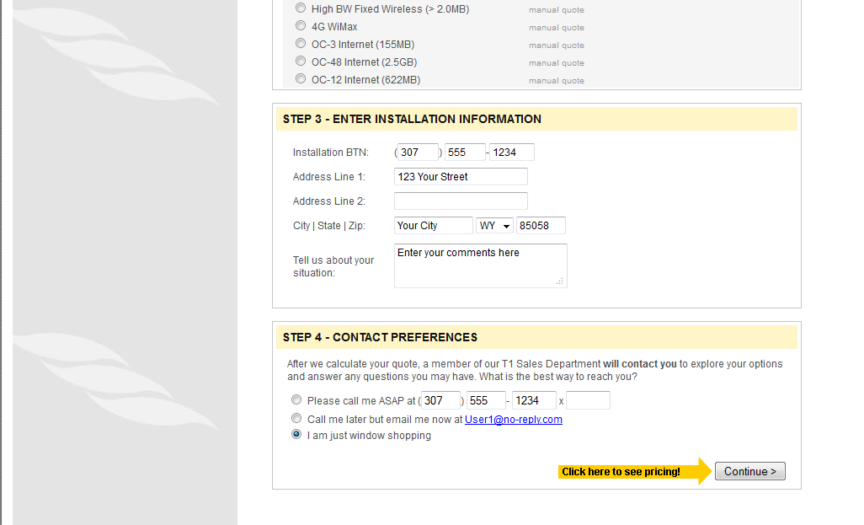

* 1. Examine the results.

You should see a list of quotes showing the available pricing of a T1 connection to the location you specified. Was the pricing in the area you chose comparable to those pictured below?

_______________________________________________________________________________________

_______________________________________________________________________________________

What was the range of prices from your results?

_______________________________________________________________________________________

_______________________________________________________________________________________

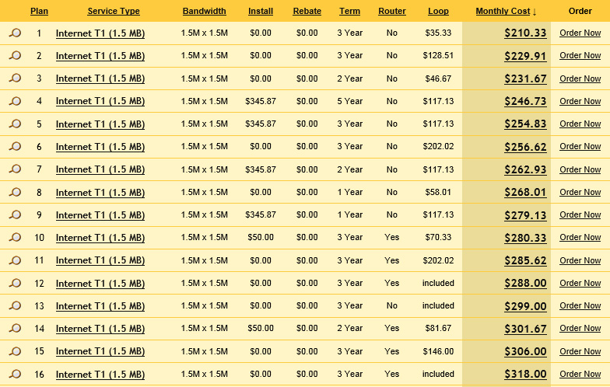

1. Reflection
   1. What are the disadvantages to using a T1 leased line for personal home use? What would be a better solution?

_______________________________________________________________________________________

_______________________________________________________________________________________

_______________________________________________________________________________________

* 1. When might the use of a dedicated WAN connection, of any type, be a good connectivity solution for a business.

_______________________________________________________________________________________

_______________________________________________________________________________________

_______________________________________________________________________________________

* 1. Describe other WAN technologies that provide high-speed, low-cost options that could be an alternative solution to a T1 connection.

_______________________________________________________________________________________

_______________________________________________________________________________________

_______________________________________________________________________________________